**Names for bug reports. Practical task #8**

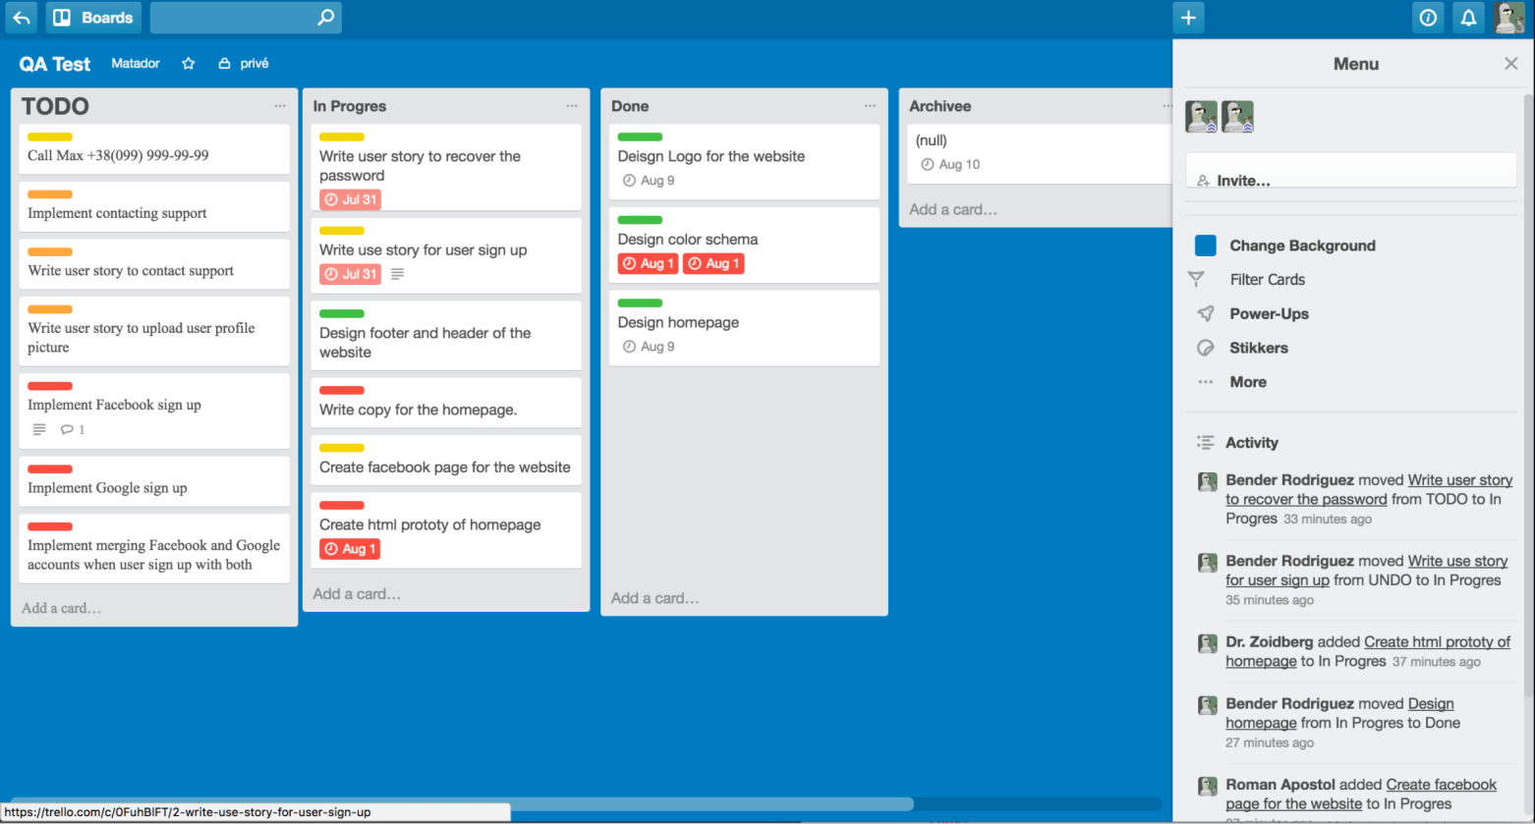

1. The "+" button is shifted to the left in the site header.
2. The button  is not localized to English.
3. The name of the To Do list does not match the general style of the page and the names of the lists.
4. The signature on the “Invite…” button is not centered outside of the button in the Menu on the right sidebar.
5. Duplicated user avatar in the Menu on the right sidebar.

(note: it is possible that two users with the same avatars are working in the program)

1. The text on the “Filter Cards” button is not marked in bold in the Menu on the right sidebar.
2. The filter icon on the “Filter Cards” button has been moved to the left in the Menu on the right sidebar.
3. Notifications about user actions are not sorted by the time they were written (from newest to oldest) in the “Activity” tab in the Menu on the right sidebar.
4. The style and font size of the “Add card…” button does not meet the requirements at the bottom of the TODO list.
5. The bottom edge of the Menu Window extends beyond the page on the right sidebar.
6. Grammatical error in the name of the "Archive" list.
7. The empty list "Archivee" contains a card with the inscription (null).
8. The “Done” list window is not formatted according to the number of cards added to it.
9. Overtime markers are duplicated on the "Designe color schema" card in the "Done" list (note: they should not be there at all, because only completed tasks are transferred to this list).
10. Grammatical error in writing the title on the “In progress” list.
11. Overtime markers have different shades of red on cards in the “In progress” list.
12. The colored stickers on the cards do not correspond to the lists to which they are attached.
13. Cards with red stickers are missing a due date marker on the “TODO” list.
14. The text of the cards does not match the style of the program text on the “TODO” list.

(note: not sure if this is a bug, since this information is entered by the user himself and suddenly there is an option to choose a font style?)